Australian Acoustical Society

A.B.N. 28 000 712 658
Western Australian Division
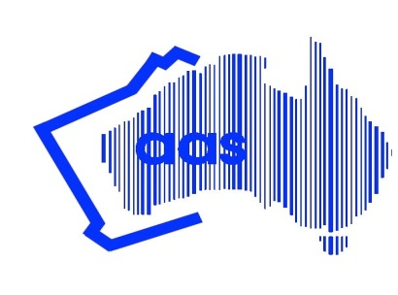Unit 3/2 Hardy Street, South Perth, W.A. 6151

AAS WA Young Scientist Award for Research Students - 2017

To assist with attendance at "Acoustics 2017", Perth, WA, November 19-22, 2017

The Western Australian Division of the Australian Acoustical Society (AAS) is offering up to eight awards of $375 each for research students who are under 35 years of age, to assist their attendance at ‘Acoustics 2017’. Total award pool is $3,000.

Successful awardees will be required to provide a short written report (200 to 500 words) to the WA Division on their experiences at the Conference. This report may be summarised for inclusion in Acoustics Australia. An alternative to this written report may be a verbal presentation, conducted at a suitable WA division technical meeting / seminar, at the discretion of the AAS WA Division committee.

The award is to be spent towards the conference registration fee, and/or travel to and from the conference. Evidence of attendance must be provided prior to payment of the award – such as a copy of conference registration receipt. Claims with supporting documentation must be submitted no more than 30 days after close of the conference.

The award is open to all research students who are AAS members, or who have applied for AAS membership (student, associate or member grade) of the WA Division, and who are presenting a paper or a poster at the conference.

To apply for the award complete the following application form, scan, save as one pdf and submit via email to the WA division secretary at: wa-secretary@acoustics.asn.au

The closing date for the applications is Friday 6th October 2017. Late applications will not be considered.

Confirmation of your received application will be emailed to you within 2 working days.

Amounts awarded may vary and will be at the absolute discretion of the AAS WA Division committee, pending number of applicants. The decision of the AAS WA Division committee will be final.

APPLICATION FOR AAS WA YOUNG SCIENTIST AWARD 2017

1. DETAILS OF APPLICANT

Applicant Details

Title: Family Name:

Personal Name:

Date of birth:

School/University:

Postal Address:

State: Postcode:

Email: Telephone:

Research topic:

List any other funding you have applied for or have been awarded in order to attend this conference (include source and amount).

Signature of applicant:

Date:

Support from Supervisor

Name of supervisor:

Email for supervisor:

As supervisor of this research student I endorse this application.

Signature of supervisor

Date:

2. SELECTION CRITERIA

Conference Paper / poster

Title of conference paper or poster submitted:

Abstract:

How will your attendance at the conference contribute to the advancement of the science and practice of acoustics?

3. CV AND STUDENT CARD

Attach one page CV including qualifications, details of your current project ie PhD or Masters, title of your research project, date you commenced, date you anticipate completion and list of any publications to date.

Include student card at the bottom of the page before scanning so that it appears in the submission file.

